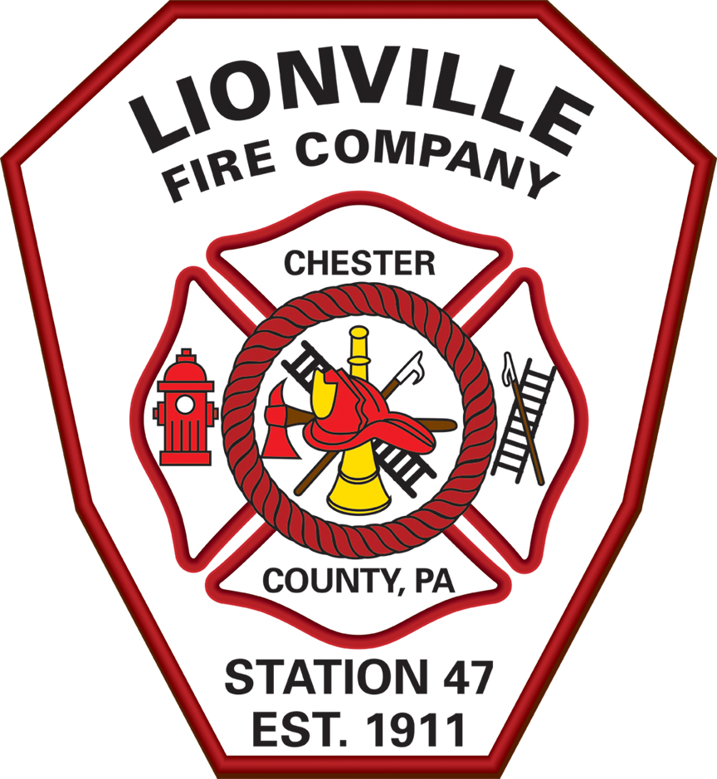
Lionville Fire Company
Proudly Serving since 1911
PO BOX 478, Lionville PA 19353
610-363-7663 lionvillefire.org

Support the
34th Annual
Robert G Holmes Memorial Golf Outing

Saturday, June 18th at the Inniscrone Golf Club, Avondale PA
with proceeds benefiting the

Lionville Fire Company

Hole sponsors are needed!! For a donation of $250.00 your business name will be displayed on a custom sign at the tee box of a designated hole. All proceeds support the day to day operations of this vital volunteer service, and all donations are tax-deductible!!

Thank you in anticipation of your support!!

****************************DETACH AND RETURN THIS PORTION***************************

Please make your check payable to LIONVILLE FIRE COMPANY in the amount of $250.00 and return to:

Lionville Fire Company
P. O. Box 478 BUSINESS NAME:_______________________________
Lionville, PA 19353
attn. Mike Holmes Hole Sponsor:____ Cart Sponsor:____ Amount:________

Questions or interest in playing- please contact Mike at 610-680-6120 or lfcochief47@aol.com

